Bandit level 4 to level 5
To login level 4 use the username as
Use level 3 password for login to level 4.
Use cd inhere command to transfer the file
Use ls -la command to list all the files.
Use file ./* command to find the file which contains the text.
After getting the text file use cat to display its content.
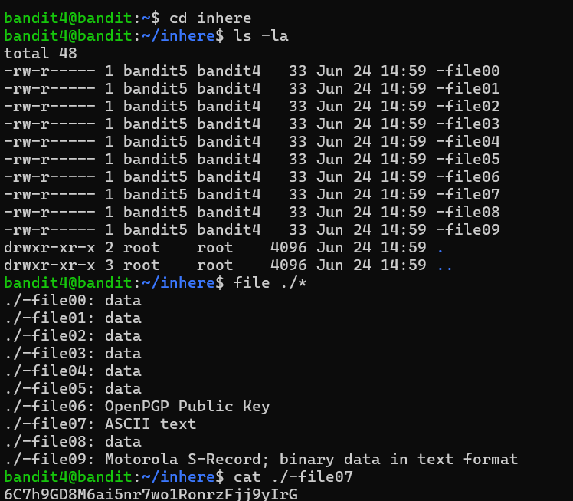
Finally you will get the password to login for the level 5 of bandit

